Nepal College of Information Technology
Assessment Fall 2010
Program: B.E.IT/CE/ELX Time: 3 hrs
Semester: Fall (I) FM: 100
Subject: Engineering Math-I PM: 50
Attempt all questions
1. a. Define Continuity of a function at a point x=c. Show that the function
f(x)=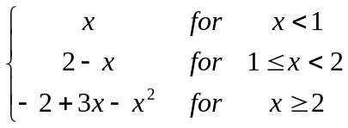
is continuous at x=1 but not differentiable at x=1 8
OR
If y=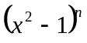, Show that
i) (x²-1)y + 2(1-n)xy₁-2ny=0
ii) (x²-1)y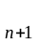+2xy- n(n+1) y=0
b. State and Prove lagrange's Mean value theorem. Interpret it geometrically. 7
2. a. A cylindrical tin can be closed at both ends and of given capacity, has to be constructed. Show that amount of tin required will be minimum when the height is equal to the diameter. 8
OR
Define asymptotes of the curves with different types. Find asymptotes of
y³-x²y+2y²+4y+x=0.
b. State L' Hospital theorem and show that
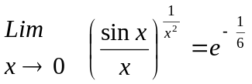
7
3. Integrate any three of the following: 15
i) 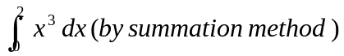
ii) 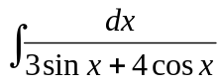
iii) 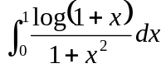
iv) 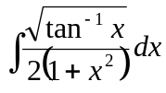
4. a. Find the area bounded by the curve x+y=2, on the left by y=x² and below by x-axis, by sketching neat diagram. 7
OR
Find the volume of the solid in the region bounded by the parabola y=x² and line y=2x in the first quadrant about y-axis, by sketching neat diagram.
b) Find the approximate area using Simpsons and Trapezoid rule for the region bounded by the curve y=x²+2, x-axis, ordinates at x=1 and x=5 taking number of subintervals 4 (i.e n=4) and compare those with exact area using definite integral. 8
5. a) Find a plane through the points (1,2,3) and (3,2,1) which is perpendicular to the plane 4x-y+2z=7. 8
b) Define vector triple product
If 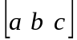=0 Show that
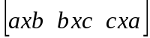=0 7
6. a) Show that the normal to the parabola y²=8x at (2,4) meets the parabola again in (18, -12). 7
b) Define eccentricity of a conic section and classify conic sections.
Derive the equation of the hyperbola in its standard form
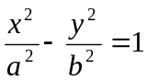. 8
7. Attempt all: 2*5=10
i) Find domain and range of the function y=2cosx.
ii) Find the radius of curvature of the curve
9x²+4y² = 36x at (2, 3).
iii) Evaluate
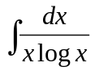
iv) If 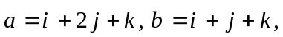 find unit vector along 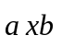.
v) Verify Rolle's theorem for
f(x)=x² in x 